***Getting Started with ROS on Jetson Nano***

***ROS is the natural choice when building a multi-sensory autonomous robot.***

***After setting up the Jetson Nano with its JetPack image using our Getting Started guide, we are going to install the latest version of ROS that runs on Ubuntu 18 Bionic Beaver: Melodic Morenig***

***Installation***

***Open a new terminal by pressing Ctrl + Alt + t or executing the “Terminal” application using the Ubuntu 18 launch system.***

***Set up the Jetson Nano to accept software from packages.ros.org:***

***$ sudo sh -c 'echo "deb http://packages.ros.org/ros/ubuntu $(lsb_release -sc) main" > /etc/apt/sources.list.d/ros-latest.list'***

***Add a new apt key:***

***$ sudo apt-key adv --keyserver 'hkp://keyserver.ubuntu.com:80' --recv-key C1CF6E31E6BADE8868B172B4F42ED6FBAB17C654***

***[Note*: the ROS GPG key has changed due to a**[***security issue on the ROS build farm server***](https://discourse.ros.org/t/security-issue-on-ros-build-farm/9342)**. If you configured your Jetson Nano for ROS**

***Update the Debian packages index:***

***$ sudo apt update***

***Install the ROS Desktop package, including support for rqt, rvizand other useful robotics packages:***

***$ sudo apt install ros-melodic-desktop***

***Note: “ROS Desktop Full” is a more complete package, however, it is not recommended for an embedded platform; 2D/3D simulators will be installed with it and they take too much space on ROM, and are too computationally hungry to be used on the Nano.***

***It is recommended to load the ROS environment variables automatically when you execute a new shell session. Update your .bashrc script:***

***$ echo "source /opt/ros/melodic/setup.bash" >> ~/.bashrc   
$ source ~/.bashrc***

***Install and initialize rosdep. rosdep enables you to easily install system dependencies for source code you want to compile and is required to run some core components in ROS:***

***$ sudo apt install python-rosdep python-rosinstall python-rosinstall-generator python-wstool build-essential***

***$ sudo rosdep init***

***$ rosdep update***

***Now the Jetson Nano is ready to execute ROS packages and become the brain of your autonomous robot.***

#### *Configure a catkin workspace*

***To start running your own ROS packages or install other packages from the source (such as the***[***ZED ROS wrapper***](https://github.com/stereolabs/zed-ros-wrapper)***for example), you must create and configure a catkin workspace.***

***Install the following dependencies:***

***$ sudo apt-get install cmake python-catkin-pkg python-empy python-nose python-setuptools libgtest-dev python-rosinstall python-rosinstall-generator python-wstool build-essential git***

***Create the catkin root and source folders:***

***$ mkdir -p ~/catkin_ws/src   
$ cd ~/catkin_ws/***

***Configure the catkin workspace by issuing a first “empty” build command:***

***$ catkin_make***

***Finally, update your .bashrc script with the information about the new workspace:***

***$ echo "source ~/catkin_ws/devel/setup.bash" >> ~/.bashrc   
$ source ~/.bashrc***

***Your catkin workspace is now ready to compile your ROS packages from source directly onto the Jetson Nano.***

***Reference***

***[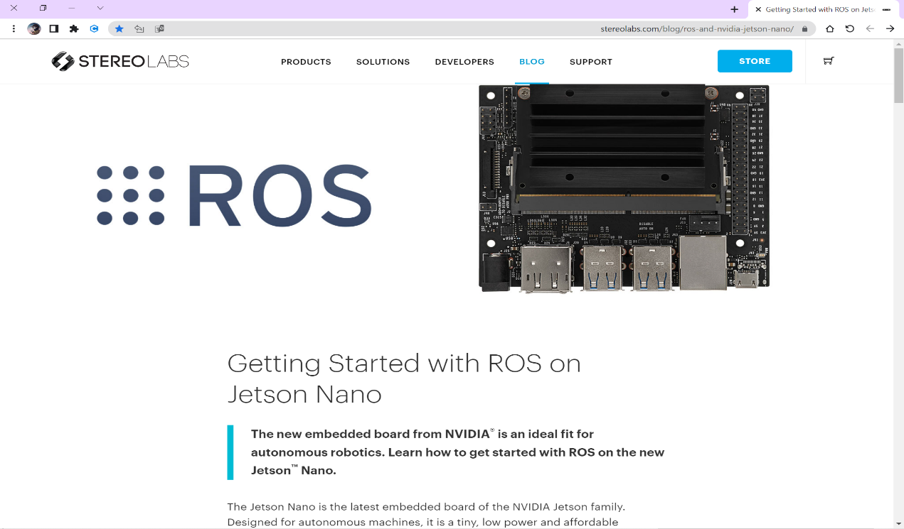](https://www.stereolabs.com/blog/ros-and-nvidia-jetson-nano/)***